2025 Citroen Racing C3 Rally2 Trophy  
**Championship Regulations  
Triton Showers Motorsport Ireland National Rally Championship**

# **GENERAL CONDITIONS & ORGANISATION**

Race & Rally NI, [R&R Logistics – (NI) 16 Longstone Street, Lisburn, BT28 1TP] (the Promotor) will organise the Citroen Racing C3 Rally2 Trophy [C3 Trophy] within the Triton Showers Motorsport Ireland National Rally Championship.

The C3 Trophy will be governed in accordance with the regulations of Motorsport Ireland, incorporating provisions of the FIA 2025 International Sporting Code (ISC) and Motorsport Ireland National Rally Championship plus any bulletins issued by the Promoter.

* 1. By entering the C3 Trophy, you agree to abide by these regulations. Anything that is not expressly authorised by these regulations is forbidden.
  2. Should any dispute arise as to the interpretation of these regulations, the matter shall be referred in the first instance to the Championship Manager. It may then be subsequently referred to the Championship Stewards who will operate under Chapter 14 of Motorsport Ireland’s General Competition Rules. Decisions of the Championship Stewards shall be subject to Appeal as provided in Chapter 16 of Motorsport Ireland’s General Competition Rules.

# **TROPHY OFFICIALS**

* 1. Trophy Manager/s: Raymond Moore & Matt Cotton  
     Trophy Media Officers: MCR Motorsport Media

# **ELIGIBILE VEHICLES & CONTROL ITEMS**

* 1. The C3 Trophy is open to Citroen Racing C3 Rally2 and C3 R5 vehicles. Each vehicle must have been originally sold by Citroen Racing and have been a factory built example.  
       
     Any parts not included in the original Rally2 kits or options are prohibited (e.g: quick couplings, additional thermal protection, etc.). Cars must run in Homologated specification – specific to their Homologation papers. Right hand drive examples are permitted but must carry a set of left-hand drive homologation papers along with photographic and text evidence of the conversion and must comply with the homologation papers in all other aspects. They must also conform to Motorsport Ireland regulations.
     1. **C3 Trophy Tyres**

All vehicles contesting the C3 Trophy must use Michelin Motorsport Tyres.

Eligible Asphalt tyres are:  
Michelin Pilot Sport A Tyres SS01/SS02 Super Soft Size: 20/65 – 18

Michelin Pilot Sport A Tyres S10/S11 Soft Size: 20/65 – 18  
Michelin Pilot Sport A Tyres M20/M21 Medium Size: 20/65 – 18

Michelin Pilot Sport A Tyres H30/H31 Hard Size: 20/65 – 18  
Michelin Pilot Sport A Tyres MW1 Wet Size: 20/65 – 18  
Michelin Pilot Sport Tyres FW3 Wet Size: 18/65 – 18

No other tyre compound is permitted unless informed via a championship bulletin. No other manufacture of tyre is permitted – any breach will result in a forfeit of prize monies for that round and removal of any allocated points on that round.

* 1. **C3 Trophy Tyre Quantities**Competitors in the C3 Trophy must adhere to any tyre limits set by regulations of the Motorsport Ireland National Rally Championship.

# **TROPHY OUTLINE AND PRIZES**

# After each rally, according to the final standings, prizes will be awarded as below:

* + 1. Prizes per rally:

|  |  |
| --- | --- |
| 1st | **€2,000  worth of Stellantis Motorsport Parts Vouchers from Race & Rally** |
| 2nd | **€1,500 worth of Stellantis Motorsport Parts Vouchers from Race & Rally** |
| 3rd | **€1,000 worth of Stellantis Motorsport Parts Vouchers from Race & Rally** |

* + 1. Based on the individual event’s final results classification, registered C3 Trophy contenders will be awarded the parts vouchers as above after each event. For the purposes of clarity, the first registered C3 Trophy crew home is awarded €2,000 in parts vouchers, the second place €1,500 in parts vouchers, third place €1,000 in parts vouchers.

# **ADVERTISING AND BRANDING**

# All vehicles must display ALL the decals as requested by the promotor in the images below. The promotor reserves the right to add to the requirements during the season via a communication.

# The penalty for non-compliance is the forfeit of any Trophy prizes for the round that the missing decals are identified on.

# Mandatory decal placement is as follows:

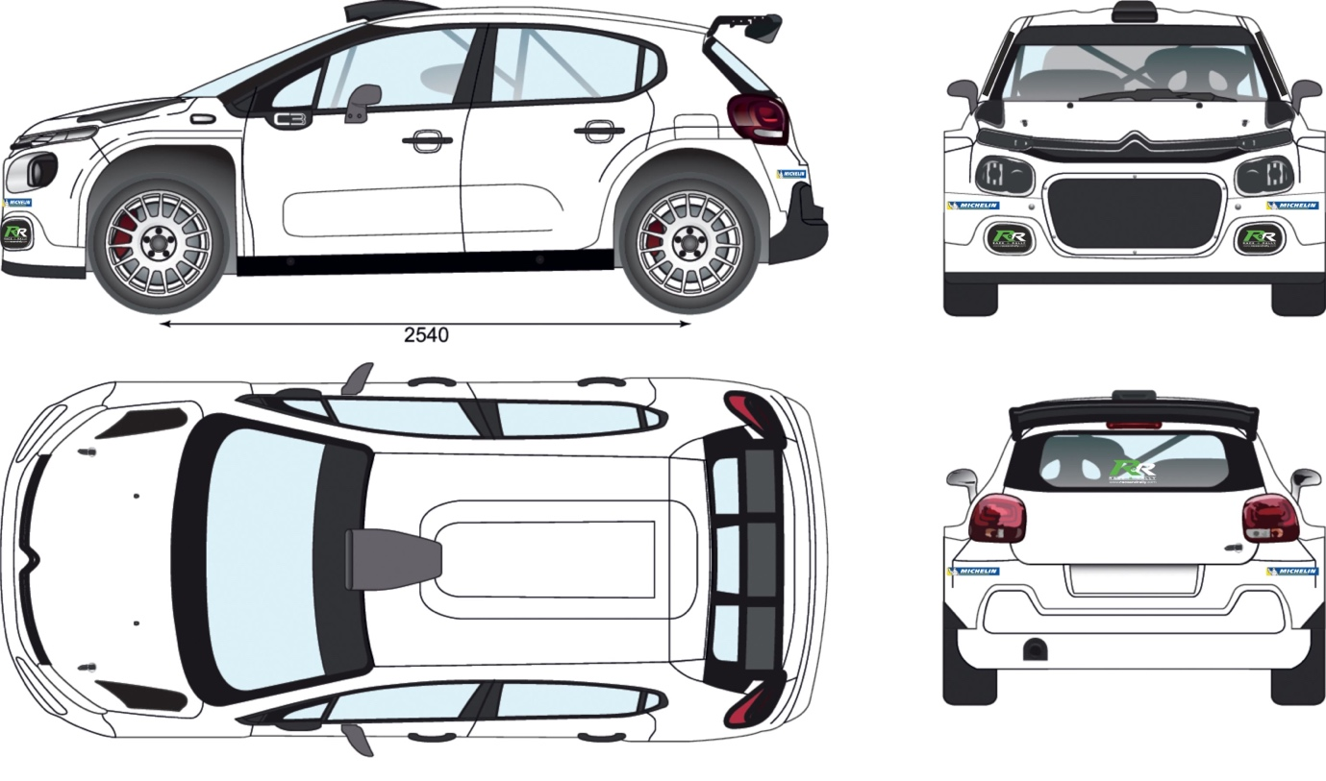

# Driver and co-driver must wear the approved cap dictated by promotor during ceremonial start and finishes and/or awards ceremonies. Failure to do so will result in a forfeit of prizes on the relevant round.

# **SCRUTINEERING AND ADMINISTRATIVE CHECKS**

# Competitors competing in the C3 Rally2 Trophy are under the jurisdiction of the officials and delegates of the rallies of the Motorsport Ireland National Rally Championship.

# The promotor will utilise the Technical Delegates of the Motorsport Ireland National Rally Championship

# Competitors must provide at least one member of the team for any inspection or disassembly during technical checks. All costs for rebuilding and reassembly will be borne by the competitor.

# Seals may be used by the championship Technical Delegates and may not be tampered with or removed.

# Race & Rally may at any time request data to be downloaded from the vehicle.

# **FINISH PROCEDURE**

# To receive any prizes, all competitors MUST attend the official event finish ceremony and awards presentation if requested by the promoter. Any driver or co-driver not attending with the car as required by the promotor, will forfeit all prize vouchers for that round.

# **C3 TROPHY REGISTRATION**

# All drivers wishing to participate in the C3 Trophy must register prior to the event with Race & Rally and complete the C3 Trophy registration form (zero registration fee). All drivers must also be registered for the Motorsport Ireland National Rally Championship to be eligible for any prize vouchers.

# **PROMOTION AND PUBLICITY**

# Each competitor and team may be requested to participate in any official media and/or promotional activity. This may include a dedicated media day or promotional events and are not limited to rounds of the Trophy. These activities will be at the expense of the competitor.

# Each competitor and team may be requested to participate in any official media and/or promotional activity.

# Failure to comply with any request to assist with promotional activities may result in loss of prize prizes.

# By entering the Trophy, competitors, are obliged to assist in the promotion of the Championship and in particular any television coverage, live streaming, radio, news media and attendance at press conferences and functions as required by the promoter/championship or sponsor.

# All competitors are obliged to assist the appointed media production company(s) in the filming and/or recording of the Championship events through the granting of interviews when requested and any other reasonable request of the media production company(s).

# **CONTACTS**

# Joint Championship Manager Raymond Moore T: 07736 553966 E: raymond@raceandrally.com

# Joint Championship Manager Matt Cotton

T: 07870 216931  
E: matt@mcrmotorsportmedia.com

# Media Officer MCR Motorsport Media T: 07870 216931 E: media@mcrmotorsportmedia.com